

Version 1.3
June 7 2008

Introduction 4
Running a Homebrew Competition 4
Menus and Windows 6
Example 1: The first annual new-parents brew-off 6
Initial Setup 12
Menu Bar 12
Participants 12
Judge Information 13
Entries 14
Add or Edit Entries 14
Multiple Brewers per Entry 15
Special Ingredients 16
Add or Edit Entries to be Received Later 16
How are unreceived entries used? 16
Receive Entries by Brewer 17
Edit Scores/Review Entries by Flight Assignment 17
Edit Scores/Review Entries By Brewer 18
Edit Scores/Review Entries By Category 18
Enter Best Of Show Results 19
Tables 19
Edit Table Definitions 19
Define Flights 20
Assign Flights to Rounds 21
Judge Assignments 21
Matrix Based Judge Assignments 21
List Based Judge Assignments 22
Data Views 23
View Winners By Table 23
View Scores By Table 23
View Winners by Table With Scores 24
View Scores By Entry Number 24
View Entries with no Assigned Scores 24
View Judges Eligible for BOS 24
View Top Scoring Brewer in Each Category 25
View Category Totals 25
Reports and Labels 25
Labels 26
Address Labels 26
Small Bottle Labels 26
Large Bottle Labels 27
Bottle Labels with Category Numbers 27
Judge Labels 28
Flight Score Labels 28
Ribbon Labels 28
Label Alignment Test 29
Pull Sheets 29
Table Pull Sheets 29
Best of Show Pull Sheets 30
Reports 30
Score Reports 31
Entry List 31
Category Totals 32
Scores by Category 32
Brewer Results 33
Judge Assignments 33
Table Cards 34
Judges Eligible for Best Of Show 34
Staff Report 34
Publish Results to HTML 34
Save BJCP Competition Report to XML 35
Print Abbreviations List 36
Utilities 36
Edit Competition Information 36
View Category Chart 37
Calibration Scores 37
Category Maintenance 37
Import/Export 39
Import List of Participants 39
Import Tab Delimited List of Entries 40
Import Tab or Comma Delimited List of Entries to be received at a Later Time 40
Export Tab Delimited List of Participants 40
Export Tab Delimited List of Entries 40
Archives 41
Archive Competition 41
Restore Competition Archive 41
Auto Generate Entry Numbers 41
Clear Judge Steward Organizer Assignments 41
Clear Table Assignments 42
Adjust Printer Offsets 42
Diagnostic Level 42
Recalculate Flight Assignments for Entries 42
Help 43
Balloon Help 43
View Documentation 43
About 43
Databases 44
Glossary 45
Category 45
Entrant 45
Flight 45
Organizer 45
Participant 45
Round 45
Subcategory 45
Table 45

HCCP
Homebrew Competition Coordinating Program
(pronounced “Hiccup”)

Introduction
I started writing this program after problems at the 9th War of the Worts. After using it for years, we discovered the venerable “BCO”, written by Barry DeLapp, would not operate correctly on any Windows operating system after Win98. Unfortunately, we discovered that about midnight of the night before the contest. Barry’s BCO provided pretty much all the functionality we required in a competition program, but the human interface was dated and awkward to use. Given a slow period of work, I have tried to incorporate all the good features of BCO in a more modern, windows oriented package. In addition, I’ve added some features which are designed to make it easier to use HCCP in larger competitions, and to provide interfaces to BJCP competition tools. I chose to use the TCL programming language to implement HCCP, which allows for rapid prototyping, changing, and bug fixes (way too many of those).

So, let me welcome you to my attempt to make homebrew competitions easier. I welcome input and suggestions for improvement, and hope you will find this one step towards removing the panic associated with getting through your competition.

Running a Homebrew Competition
There are many steps to conducting a successful homebrew competition. You must find a location and date, solicit prizes, invite judges, announce the competition to the public (especially former entrants of your competition), perhaps specify some specialty categories unique to your competition, receive and organize entries, usually combine categories based on the entries to make judging tables of a manageable size, perhaps divide tables into judging groups so that individual judges don’t need to taste 30 individual IPA’s, separate judging into morning and afternoon sessions, make it easy for the judges to find their places and for the stewards and judges to know which beers they are judging and how to get them from the cooler, conduct a calibration round, record the judges assigned scores and places, determine what beers should be in a “Best of Show” round, conduct that round, report results back to participants, publish results on the web or elsewhere, and finally report competition information back to the BJCP for recording of points. While HCCP will not find a location for your competition or ask people for prizes, it will aid in all the other activities above.

- Soliciting judges – HCCP will import the BJCP judge data as supplied to competition organizers, and has an option to generate mailing labels for anyone in the database with a BJCP ID number
- Announcing the comp – You may maintain participant databases from previous contests, or import tab-delimited files of people, and use that to information to generate mailing labels for announcements.
- HCCP provides two default style sets, both the current (2004) BJCP styles, and the previous BJCP style guidelines from 1999. In addition, it is easy to modify or add categories to the list of styles, or even make up an entirely different set of styles. As examples, the HWBTA wine categories, and even a simple set of salsa categories, are included.
- Organizing entries – HCCP will optionally generate entry number labels (either sequentially or randomized within a range) which may be affixed to bottles and entry forms as soon as they are received. Once entries are recorded in the database, they may be viewed and edited in a wide variety of ways. Entries may be either entered manually in an extremely quick and efficient manner, or imported via a provided mechanism in a specified tab-delimited file format.
- Collapsing categories for tables – HCCP has an easy point and click mechanism to assign categories to tables. As it is done, a count of entries in the table is automatically updated, and the unused category display is adjusted to show remaining entries.
- Flights within a table may be specified in such a way that subcategories are divided evenly across the flights, or specific subcategories are assigned to specific flights. This is completely at the organizer’s discretion.
- Judges can be assigned to individual judging stations via either a matrix based display in which you simply click on the intersection of a judge and table, or via a list based display where judges are selected from a listing. In either case judges with an entry in a table are prevented from being assigned to that table, and judge preferences and dislikes (an unlimited number of each, by the way) are indicated when assigning the judges, as is their BJCP judging rank.
- Flights can be assigned to an unlimited number of “rounds” (usually morning and afternoon, but if you have a 3 day contest, more power to you). Judges are assigned by round, meaning a judge can be assigned without conflict to both the first and second rounds, if appropriate.
- HCCP produces large table cards for each table in a round, optionally showing the judges assigned to that table.
- HCCP includes a simple calibration calculator. Just enter scores as reported, and the minimum, maximum, and average scores will be displayed.
- HCCP will produce large, easy to read Pull Sheets, which show the entry number, style and subcategory entered, any special ingredients, classic style, stillness, or sweetness that may be appropriate for that category and subcategory, as well as large boxes where pull order, score, and place may be entered.
- Scores and places may be entered in a variety of ways, but the most important is “Review scores by Flight” which is designed to look like the pull sheet, and allow quick entry of results as reported by the judges.
- HCCP will generate “Best of Show” pull sheets, showing any entry which received a place of “1”.
- Results may be printed or dumped to a file in any of several ways, including just those entries that placed, all entries, with scores included, without scores included, and showing or not showing the clubs with which participants are affiliated. In addition, a facility provides generation of an HTML report which may be directly incorporated into a web page.
- HCCP provides an interface to specify point awards for judges, and directly generate an XML file which can be read by the BJCP database. You simply need to email the output XML in to complete your report.

Menus and Windows

Many of the windows used in HCCP are free-floating, and may be left on the screen while other activities are done. For example, the category chart may be displayed while adjusting tables, or the “Edit Scores/Review Entries” dialogs may be viewed while looking through the table definitions.

In addition to the floating windows, many of the menus from the menu bar can be converted to floating windows also. Any menu which is displayed with a dotted-line at the top can be left in a separate window by clicking on the dotted line. For example, while running a competition you might wish to have the “Data Views” readily accessible. Clicking on the dotted line of that menu will display a window for quick access to each of the data views.

Examples

What follows is an example, in brief outline, of how HCCP could be used to organize a homebrew competition. Specific details of how to use specific functions will be discussed later.

Example 1: The first annual new-parents brew-off

In this case we are starting a brand new contest. We expect 100-200 entries, maybe 20 judges, and would like to a have a special category: “Beers that taste like baby diapers”, which divides into two subcategories, “infected beers” and “lambics”.

- First we decide what base set of categories we want. We’ll start with the BJCP 2004 categories, which happen to be the program default. (The 2008 revision did not modify categories) However, they can be specifically selected from the “Utilities” menu bar item, by selecting “Category Maintenance”. The “Load a Category and Style Set” button will bring up a list of available styles for selection.

- From that same menu item, we can add the specialty category. Enter a category number, (for example 99), and a title, and click Add/Update Category. Subcategories are entered in the same way. Each category must have at least one subcategory defined, so we’ll enter subcategory ‘A’ as “Infected Beers” and subcategory ‘B’ as “Bad Lambics.”

Now’s also a good time, by the way, to enter the information about the contest. From the “Utilities” menu bar item, select “Edit Competition Information.” Here you can enter the name of the competition, the date, the sponsoring organization, and the BJCP competition ID.

- Having cleverly registered our contest with the BJCP, they have sent a file which consists of a tab-delimited list of judges in our area. This can be directly imported into HCCP. Select the “Utilities” menu tab, Import/Export, and “Import Tab delimited list of Participants.” You can browse to the file provided, select it, and let HCCP read in the data. Now we can print mailing labels for these judges, so that we can send them the four-color glossy flyers we have. From the “Reports and Labels” menu tab select “Labels” and then “Address Labels”. Select the button that says “People with a BJCP ID”, load the printer with Avery 5160 or equivalent labels, and print.

- Now we need to get ready for the entries that are going to pour in. Let’s say you have one main collection point to which entries will eventually be brought. From “Reports and Labels”, “Labels”, “Bottle Labels” specify you want labels from 1 to 200, click “Randomized Order”, load the printer with the self-same Avery 5160 labels, and print. On each label will be two rows of numbers, each row having the same number repeated 7 times. Take an X-Acto knife or similar and a straight edge, and score down between the numbers, cutting each label into 14 smaller ones. As each entry is received an identical number is placed on the neck and cap of each bottle, and on the top of the entry form. The bottles and entry form are all now marked with the same entry number. Any entry forms attached to the bottles can now be removed.

- As the entries come in, the participants and entry information can be entered. From the “Participants” menu tab, enter the first few letters of the participant’s last name. If they are already in the database, the list on the right will scroll to that entry. If they are in the list, double clicking or entering “return” in the last name field will load the data for that participant for modification, if necessary. If the participant is not in the database, enter the appropriate information on the screen (only Last Name and First Name are required, though you will need address information later) and save the participant.

- Adding entries is done from the “Entries” Menu tab, selecting “Add or Edit Entries.” Shown at the right of this window are two lists, one of people in the database, and the other of current entries. Clicking either will load the information. To add a new entry, type the first few letters of the entrant’s last name, and select the entrant from the list. Entrants must be in the database before entries can be added for them. To add an entry, enter the Entry number, <Tab>, Category, <Tab>, Subcategory, <Tab>Name of the entry if desired, <TAB>. If the category and subcategory allow special information you will be positioned on them, otherwise on the “Add this Entry” button. Once there, the “Enter” keyboard key will add the entry, and position you back to the entry number field for more entries by the same brewer.

- Once you have entrants and entries in the database, you need to figure out who your judges are going to be. Many will be people who already have entries, but others may be people from your earlier mailing to BJCP judges, or may be people from neither list. Fortunately, the first two categories are already in your database. Just go to the “Participants” menu bar item, scroll to the appropriate participant (or type a few letters of the last name until it is selected) select the participant, and click the “Judge” box. You do not need to worry about which categories a judge has entered, the program will take care of this for you, but you may wish to enter any preferences or dislikes the judge may have.

For either dislikes or preferences, enter the category and subcategory (leave the subcategory blank if the judge likes/dislikes all of them) and hit “Add/Remove as Preferred” or “Add/Remove as Dislikes.” The buttons will toggle the selection of values in each of these categories, and the preferences/dislikes will show up when judge assignments are done later.

Now is also a good time, by the way, to indicate who is stewarding or serving as an organizer for the competition. It will be useful later when you generate reports. Note that while I indicate these things should be done at this stage in the process, there is no hard and fast rule. Each of these steps can be done anywhere in the competition timeframe, so if judges or stewards wander in at the last moment, just add them, HCCP will handle it.

- Now you have an unorganized mess of entries, but no way to organize them for judging. Chances are you would like to have each set of judges judge 8-12 entries, but of course the entries don’t arrange themselves neatly into categories like that. Select the “Tables” menu bar item, and “Edit Table Definitions.” On the right you will see a list of all the categories which have not yet been assigned to tables, and in the upper left, a list of defined tables. If there are any tables defined you can work with them by simply double-clicking the table name, but your first time in there are probably no tables already made.

A little more art than science is now needed. Look at the list of categories on the right, and get an idea for how you would like to combine them for judging. When you have an idea for a table, give it a number (they don’t need to be consecutive) and a name. Then double-click the categories to the right, and they will be added to your table. A running count of entries assigned to the table is shown on the display. Your goal is to get tables defined with a judgeable number of entries in each.

- Of course, Murphy being who he is, you may not always get tables with few enough entries for a single set of judges. You may have 20 American Barley Wines entered (more than you should probably have a single set of judges sit through), or you may only have prizes or ribbons for 10 tables, but things naturally divide into 20, or whatever. Now is when you need to consider dividing tables into flights.

Save your table definition, and from that table select (at the bottom) “Define Flights.” Unless you have already defined flights for this table, you will see the table number and description, number of entries, and an entry field labeled “Enter Number of Flights.” Determine how many individual judging sessions you would like to divide this table into, enter it in this field, and press return. You are shown a table, with that many flights, and each of the subcategories you have assigned to this table, and the number of entries in each of them.

Below each subcategory are entry fields. In these you enter the maximum number of entries in each subcategory that you would wish to have assigned to each flight. If you simply have 20 American Barleywines in the table, enter “10” for flight A, and 999 (to take care of any late entries) in flight B. The first 10 ABW’s will go to flight A, and the remainder to flight B. For now, enter a ‘1’ for the round field of each flight.

On the other hand, if you have 10 ABW’s in the table, and 10 Imperial Stouts, you need to decide if you want each flight to judge 5 of each, or one flight to have the Stouts, and one flight to have the Barleywines, before coming together for the mini-BOS. In the first case, enter “5” and “5” under the categories for Flight A, and again, 999 for each under flight B. Alternatively, you could enter 999 under flight A for the Barleywines, and 0 for the stouts, and reverse that for flight B. In that case, Flight A will get all the Barleywines, and Flight B will get all the stouts. It’s your choice.

- Do you do all your judging at once? Chances are you don’t have enough judges for this, and many, perhaps most, homebrew competitions divide their judging into morning and afternoon sessions. For really large contests, you may have multiple days, each with a morning and afternoon session. You may have noticed on some of the table and flight assignment dialogs a ‘Round” field, which defaulted to 1. By setting the round to something greater than 1, you are assigning that flight or table to a later judging session, and HCCP will take account of this when you assign judges. You may change the round assignment from the table or flight definition dialogs, or more easily, from the “Tables” menu bar item, selecting “Assign Flights to Rounds.”

When first displayed, this will show a matrix with the flights along the left, and the rounds across the top. It will adjust the matrix for the highest flight number you have already specified, so if you have not already entered any flight information, it is likely to be a single column, and not very informative. In the “Total Number of Rounds” field, enter the number of rounds you would like to have. This would probably 2 for a one-day competition, 3 or 4 for a 2 day competition, or more if it makes sense to you. When you press “return”, the matrix will be adjusted to include the number of rounds you have specified. Assign flights to rounds by clicking on the radio buttons, and the number of entries in each round will be dynamically updated to show the total number of entries. When you are happy, hit “save”.

- Now it’s time to assign judges to tables and flights. HCCP provides two mechanisms for doing this.

If you have on the order of 30 or fewer judges, and 15 or so flights/tables per round, the Matrix based judge assignment is probably easiest. Click the “Judge Assignments” menu bar item, and select “Matrix Based Judge Assignments.” This will display a table showing the judges names and judge ranks along the left hand side, and the table/flight numbers across the top. In each case, if a judge has an entry in the specified table (whether or not the exact flight if it is a multi-flight table) that selection will be blacked out for them, and it may not be selected. If the judge has specified a preference for a category included in a specific table it will show in green, and if they have specified a dislike for a category, it will show in red. Click in the column matrices; HCCP will prevent you from assigning a judge to more than one flight.

Alternatively, you may wish to view a list of judges available for each flight. From the “Judge Assignment” menu bar item, select “List Based judge assignments.” This will show a list of tables/flights in the upper left. When you select one of these by double-clicking, any judges currently assigned to that flight will show in the “Assigned Judges” list, and any available judges will show to the right. Available is defined as not having an entry in the table, and not already being assigned to a flight. Judges with a preference for a table will show with a leading “+”, and judges which do not like the category will show with a leading “⌐”. Again, select judges by double clicking, or deselect them by double clicking in the “Assigned Judges” list. The interface mimics the assignment of categories to tables.

You may notice at the bottom of this page a checkbox labeled “Leave Assigned Judges In Available List.” Checking this does what it might seem: judges already assigned to a table are still listed as available. This is a special accommodation for competitions which reassign judges to new tables as soon as they complete one, essentially eliminating the idea of “rounds.” It may be useful in that particular case, but be aware that it turns off one of the more powerful features built into HCCP.

- Having defined tables and flights, and assigned judges to them, it’s time to prepare the paperwork for each judging station. First we would like to print table cards, which show the table number, and flights, in large print so bleary-eyed judges can find them. From the “Reports and Labels” Menu Bar item select “Reports” and then Table Cards. A list of flights will be shown at the right. Select the ones you want to print. You may also, optionally, click the checkbox which is labeled “Show Judge Names.” If you do, the Judges assigned to that table will be printed on the table card. Click “Print Selected Tables”, select your printer, and the table cards will be printed.

Now you might want to print the pullsheets for each table. These list the entry numbers, categories, and any special information related to each entry. From the “Reports and Labels” menu bar item select “Pullsheets” and “Table Pull Sheets”. Select the tables for which you want to print pullsheets, and specify the number of copies. The “Copies” field defaults to 3, so there is one for each of two judges, and one for the steward. Pullsheets include spaces to indicate a pull order for the steward, and the scores award and place awarded for each entry.

In place of entry coversheets, HCCP can print “Flight Score Labels.” These have the fine print from the normal cover sheets stating that consensus scores are not necessarily averages, yada yada, as well as a place to enter the assigned score. The judges can put one on one of their scoresheets, and write in the assigned score.

Finally, you may wish to print judge labels for each judge. In this case each judge gets a set of labels for the entries he is to judge. The labels include the entry number, category and subcategory the entry is entered in, the Judges name, and his BJCP judge rank. He can simply peel each label and put it at the top of his score sheet, eliminating the need to enter all this information on the score sheet. From the “Reports and Labels” menu bar item select “Labels” and Judge Labels. Select the round number, and the judges for which you would like to print labels, and click “Print Labels for Selected Judges.”

- OK, ready to start judging? Well, not quite. Most comps will have a calibration round, to make sure all the judges are roughly on the same page. Usually some brew is passed out, and judges are told to judge it as style ‘X’, whether or not that is the style it was actually brewed to. With the exception of a few insecure local microbrewers, most people will not care about the comments on the score sheets. We really want the average score, and a range. Pass out your calibration round, and collect the responses. In HCCP select “Utilities” from the Menu Bar, and “Calibration Scores.” The cursor is positioned in an entry field. Enter the first score, press return, enter the next score, and continue until all are entered. HCCP will show the total number of calibration scores entered, as well as the minimum, maximum, and average.

- Ok, let your judges, stewards and staff do what they came to do. The judges should make sure that one pull sheet, with the appropriate scores entered as well as indications of 1st, 2nd, and 3rd place, are returned to the organizers. As they are returned, select “Entries” from the menu bar, and then “Edit Scores by Flight Assignment.” Select a flight, and the display will look much like the pullsheet. Tab through the entries entering scores, and then tab through entering place position. Despite the fact that most competitions will only acknowledge 1st, 2nd, and 3rd, in a category, HCCP includes 4th and HM for “Honorable Mention.” Whether or not you use them is up to you.

Note: For tables with more than one flight, it is up to the judges to have a mini-BOS to determine 1st 2nd and 3rd. Each flight reporting may not necessarily have a 1st, 2nd, and 3rd. Similarly, there may be multiple entries awarded each level, if the judges can’t reach a verdict. HCCP does not care how many entries in a table are awarded a 1st, 2nd, 3rd, or whatever.

- Have Lunch. Have your second round.

- At this point, you should have received scores for all the entries, in all the flights. You can double check by going to the “Data Views” menu bar item, and selecting “View entries with no assigned score.” With luck, you won’t find any! You can review your winning entrants by selecting “Data Views” and “View Winners by Table.”

- Chances are you will have a “Best of Show” Round with the winners from each of the tables. HCCP helps with this in a number of ways. First, it will print Pullsheets for your Best of Show, selecting any entries with a “1” in the place field. Some particularly nasty judges may have decided not to award a first place. In that case, nothing from that table will show in the BOS pullsheet. If, on the other hand, they awarded a tie and gave two entries a ‘1’, they will both show in the BOS pullsheet.

You also need to resolve the classic good news/bad news problem for judges. “The good news is we’d like you to judge Best of Show. The bad news is none of your entries made it…” Under “Data Views” you can view the judges in your competition who do not have an entry that qualified for BOS. If you wish, you can get a print out of this from “Reports and Labels”, “Reports”, “Judges Eligible for BOS.”

After the BOS round, enter the results. If entered, these will appear at the bottom of score reports, in the HTML file generated, and the 1st BOS will automatically be included as a comment in the XML report generated for the BJCP.

- Now that the competition is over, the headaches for the organizers are just getting started. You need to send score sheets back to the entrants, publish results, report to the BJCP, and so forth. From “Reports and Labels”, “Labels”, “Address Labels” you can select the option to print address labels just for entrants in the competition. This will print those specifically for the people who entries in the competition.

To make it easy for entrants to associate there entries with scores, especially if they had more than one entry in a given category/subcategory, HCCP will print a list of an entrant’s entries, along with the entry number, name, category judged, score, place, and so forth. Select “Reports and Labels”, “Reports” and “Brewer Results.” If included along with the score sheets, this information will give a good summary to the brewer of how his entries fared.

- From “Reports and Entries,” “Reports” you can select “Score Reports” which gives you the option of printing a report showing results by each table. You can optionally include the scores or just show the places, and optionally include all results, or just those who placed.

You have the same options under “Reports and Labels,” “Publish Results to HTML.” In this case, though, you generate an HTML file which could be published immediately on the web, or modified to include whatever other information you desire.

- One final step. You need to report to the BJCP about the participants and points awarded to them. From “Reports and Labels” select “Save BJCP Competition Report to XML.” You are presented with a dialog showing the information needed by the BJCP. If you entered competition information earlier, in step 2, it will be filled in. Judging Sessions will be filled in based on the number of rounds you defined, and Entries in BOS round will be guessed at, based on the number of entries assigned a place of “1”. You can, of course, change any of these fields.

Next will be a list of everyone in the database who is marked as a Judge, Steward, or Organizer. Next to them, as an aid, is listed this designation, but you must select a role for each person from the list of approved roles. Click “Select Role” and pick one of the listed items. These are the only valid entries. You must also assign the Judging and Non-Judging points for each person.

At the bottom of the dialog is a free-form comment field. You may enter any information you wish in this field, but at a minimum it should include the email address and name of the person submitting the report. When complete, click “Generate XML File” and save the results to a file. This may then be emailed directly to the BJCP bypassing the need to retype the information online or generate a paper report.

- That wasn’t so hard, was it? Relax, don’t worry, have a homebrew!

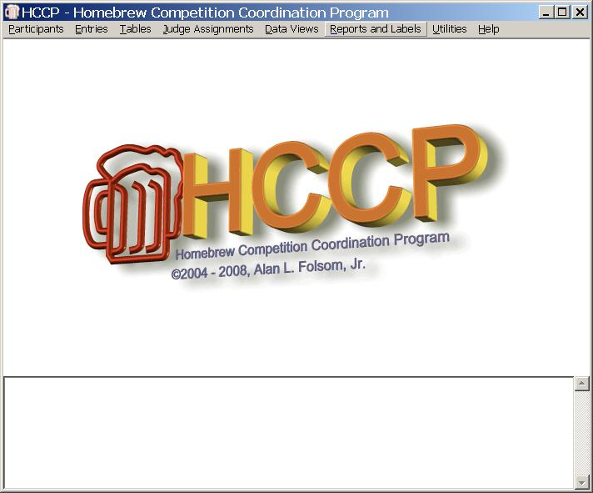
Initial Setup
When HCCP is first started, two display areas are provided. The upper contains a program logo, and will eventually be used for Participant, Entry, or Table operation. (Other displays will be shown in separate windows.) The bottom portion of the display is used for diagnostic and informational messages.

Menu Bar
The menu bar contains “Participants,” “Entries,” “Tables,” “Judge Assignments,” “Data Views,” “Reports and Labels” “Utilities” and “Help” (not much of that, I’m afraid). Each of these will be discussed in detail in the sections to follow. Many of these menus are shown with a dotted line at the top. Clicking on that dotted line will convert the menu to a free-floating window which may be left on the screen.

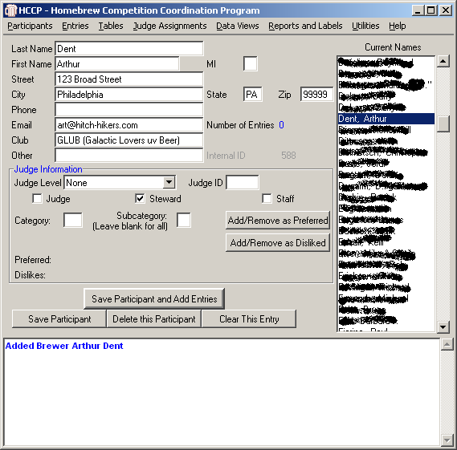
Participants

HCCP treats all people associated with your competition as “Participants”, whether they are judges, staff, people on your mailing list, entrants, or whatever. The “Participants” menu item is where all data regarding people is entered. You may add new entrants, edit data regarding current entrants, delete people, and so forth. Entry in the “Last Name” field will scroll the listbox to the closest name to what is typed. To modify a current entrant you must double-click on the listbox entry to select that person.

The “Other” field is available for (surprise) other information your competition may want to record. You can use this for sarcastic comments regarding judges who are always late, or whatever. When importing data from the BJCP supplied judge list, the nickname field is loaded into the other box.

The three buttons at the bottom of the dialog allow you to save participant information, delete a participant from the database, or clear the fields on this dialog. A common requirement after entering a participant is to immediately add entries for them. The larger button above the other three will save the participant information, and immediately access the entry dialog, with that participant already selected.

With the cursor in the “Last Name” field, the PageUp and PageDown keys may be used to quickly scroll through the list of participants.

Judge Information
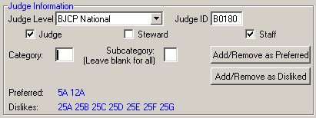
The “Judge Information” portion of this window is only of importance for people selected to judge. To indicate that someone is a judge, check the “Judge” checkbox. You should also enter their Judge ID number, and scroll through the Judge Level box to select their Judge rank. If someone is checked as a judge, they will appear in the “Judge Assignments “ table, discussed later. Similarly, if someone is serving as staff or steward for the competition, this should be indicated by selecting the correct checkboxes.

Many judges have particular categories they like, or do not like, to judge. To indicate this, select the category number and subcategory letter, and click the “Add/Remove as Preferred” or “Add/Remove as Disliked.” This will toggle the display of those categories in the Preferred or Dislikes line, and indications here will show later in the “Judge Assignments” table. These preferences may be entered very quickly by using the tab and enter keys. Enter a category, tab, enter a subcategory, tab to Preferred or disliked, press enter, and the information will be registered, the category/subcategory boxes cleared, and the cursor repositioned in the Category entry box. If a particular judge dislikes or likes all subcategories of a category, just leave the subcategory blank when entering the data.

Changes to the participant information must be saved by clicking “Save Participant” or “Save Participant and Add Entries.” If you do not select either of these buttons, any data entered will not be saved.

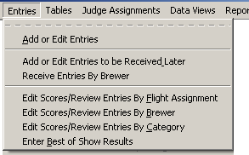
Entries

The “Entries” tab provides the ability to add entries, register entries which are not yet received, and enter scores in a variety of ways.

To enter entries, the participant (brewer) must already be in the database! Entries are tagged with a unique ID of the brewer, and this must already exist.

Add or Edit Entries
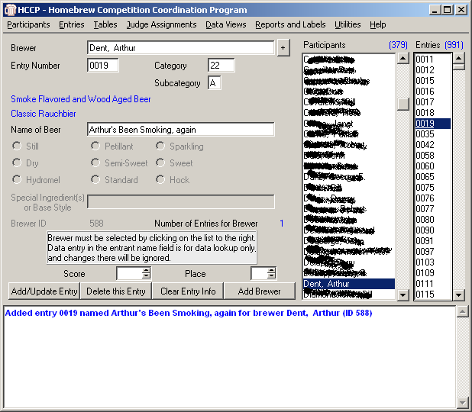
Under the Entries menu item you may select “Add or Edit Entries”. This brings a window containing a list of the current available participants, and another of the currently defined entries. The total number of participants in the database, and the total number of current entries are indicated at the top of the list boxes.

Double-clicking one of the listed entries will load it for modification or review. Double clicking in the “Current Names” list will load the information for that participant. Typing in the “Brewer” field will scroll the “Names” list to make selection of participants easier, selecting the closest name to what has been typed. Pressing “return” in the Brewer field will load the information for the highlighted entrant in the list.

Once a participant is selected, you create an entry by entering an entry number, category, and subcategory. As you enter Category and Subcategory labels, the text for that category and subcategory will be displayed in blue, allowing you to double-check the entry. You may also enter a name for the Beer. In addition to the fun factor, this will later allow brewers to differentiate when they have multiple entries in the same category and subcategory.

Note that there are entry fields for Still/Petillant/Sparkling, Dry/Semi-Sweet/Sweet, and “Special Ingredients or Base Style”. These are only available for an entry if appropriate for the selected style. If you feel you really must allow a still pilsner, or a classic style specification for an altbier, you may modify where these are allowed in the “Category Maintenance” portion of the utilities menu. The 2005 BJCP style guidelines added Hydromel/Standard/Hock for meads. These will be active for meads, and again may be modified in the “Category Maintenance” utility.

Again, entries may be added very quickly using tab and enter. Enter the entry number, tab to Category, enter it, tab to subcategory and enter it, tab to name and enter if required. If the optional fields are valid for this entry the tab key will take you there, otherwise to the “Add” button. Pressing <enter> there will add the entry, clear the number, category, subcategory and name fields, and reposition the cursor at the entry number field for the next entry from that brewer.

Score and Place may also be entered at this dialog, though this is not usually done until after judging is complete.

With the cursor in either the Brewer or Entry Number fields, the PageUp and PageDown keys may be used to quickly scroll through the current entries.

Multiple Brewers per Entry

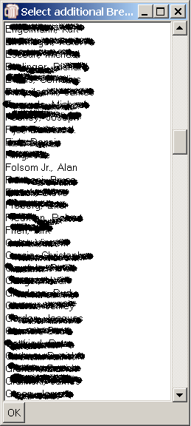
The situation where multiple brewers combine for one entry creates a problem in HCCP. Multiple Brewers should be acknowledged, and if the brewers are also judges, they should also all be blocked from judging in that category. On the other hand, you need to access the entry information indexed by a single brewer, and there should only be one address to send results.

Beginning with version 1.2, HCCP provides a mechanism to handle this issue. To the immediate right of the brewer’s name on the entry field is a button marked with a plus sign. Clicking this button will bring up a selection list of participants, which allows for multiple selection. There is no maximum number of additional entrants that can be assigned to an entry.

When complete, click the “OK” button at the lower left. This will save the assignments to temporary memory, however they will not be saved permanently until the “Add/Update Entry” button is used to save the full set of entry information.

Additional Entrants are used when calculating who is eligible to judge which flights. On the various “Data Views” to be discussed later, entries with additional entrants are indicated by a “(+)” after the primary brewer’s name.

On the score reports available from the “Reports and Labels” tab, all additional entrant names are listed after the primary entrant.

Special Ingredients
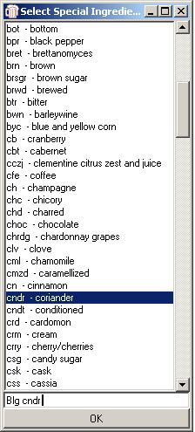
When editing “Special Ingredient(s) or Base Style”, it is possible to select from a list of standard abbreviations. HCCP at startup looks for a file named “ingredients.txt” which consists of abbreviation followed by a tab character, and the item that is being abbreviated. If this file is found, you can Right-Click on the entry field, and a dialog will pop up, with a list of the abbreviations. HCCP ships with a comprehensive list of ingredients, but you can edit this file however you wish, ort remove it all together, disabling the feature.

Clicking on any of the abbreviations in the list will add them to text field at the bottom of the dialog, and Clicking the “OK” button will insert that text into the Special Ingredients field on the main entry dialog. Of course, both fields can be edited by hand without using the abbreviations.

The abbreviations provided are from the 2004 Great American Beer Festival. They are read from a simple text file “ingredients.txt” which is distributed with HCCP. To modify the abbreviations, you may use Notepad or a similar text editor. Each line must consist of an abbreviation, a tab character, and then the text for which the abbreviation stands.

From the “Reports and Labels” menu item you may print a list of these abbreviations to distribute to judges, should you so desire.

Add or Edit Entries to be Received Later

Many competitions use an online entry system, and wish to have information regarding entries in the database prior to actually receiving them. Competitions also frequently allow judges to bring their entries with them the day of the competition. Often these entries can not conveniently be assigned entry numbers until they are actually in hand.

To make handling of such situations easier, HCCP maintains a second complete database of entries, which are considered to not be ready to use yet. Clicking on “Add or Edit Entries to be Received Later” brings up a dialog identical in every way to the “Add or Edit Entries” dialog, and entry information can be entered in the same way. The one difference is that entry numbers need not be assigned at this point. If you chose to assign them, they are independent of the numbers in the primary entry database.

How are unreceived entries used?

Entries in the unreceived database are normally ignored by HCCP in its calculations. Labels, reports, and so forth do not access this database.

There are two main exceptions to this. When assigning categories to tables and flights, the total number of entries in the category, table, or flight is indicated. This includes the unreceived entries, so that accurate table definition is possible. In addition, when judges are assigned to tables and flights, the entries in the unreceived database are also checked to determine if a judge has entries in a particular category, and therefore is ineligible for it.

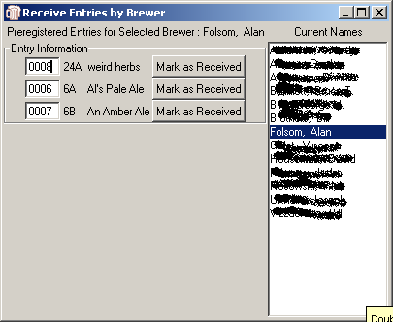
Receive Entries by Brewer

Entries which have been marked as to be received later must be transferred to the primary entry database before they will be used for pullsheets, labels, and so forth. To “receive” a particular entrant’s entries, use the “Receive Entries by Brewer” menu item.

A dialog is shown with the list of brewers who have entries in the “To Be Received” database. Selecting one of those brewers displays the entries associated with the brewer.

If an entry number has been assigned to the entry previously it is shown, but it can be changed at this time if desired. Of course, before an entry can be received, it must have a unique entry number assigned to it. If you attempt to receive an entry with no entry number or an entry number that already exists in the primary database it will fail, and you will be prompted to enter a new number.

The “Mark as Received” button associated with each entry will transfer all information regarding that entry to the primary database, and remove it from the “To be Received” database.

Edit Scores/Review Entries by Flight Assignment

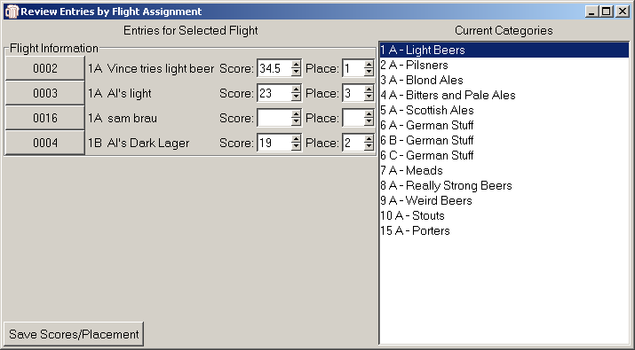
Under the “Entries” menu item you may also assign and review scores. The first option is to enter by “Flight Assignment.” Normally this will be the preferred mechanism as results are reported. Select the flight you wish to edit from the list to the right by double clicking a flight, and the entries for that flight will be listed, along with their categories, names, score and place entry fields.

Tab between the score fields to enter data. The score fields have arrows which will increase or decrease the score by increments of .5 from 12 to 50. Any numeric value may be entered, though, if you have anal-retentive judges who insist on taking scores to three or more decimal places.

Similarly, you select a placement for that entry by using the arrows or entering data. Valid results are: “1”, “2”, “3”, “4”, “HM” (for honorable mention) or blank. Other values may be entered, but they will be ignored by HCCP. It looks specifically for the values above when printing category results, and determining Best of Show qualifiers.

The entry numbers are buttons, which will take you directly to the entry dialog with that number entry selected. This may be useful for reviewing special ingredients or similar purposes. When you have entered or modified scores, click “Save Scores/Placement” to save your data.

Edit Scores/Review Entries By Brewer
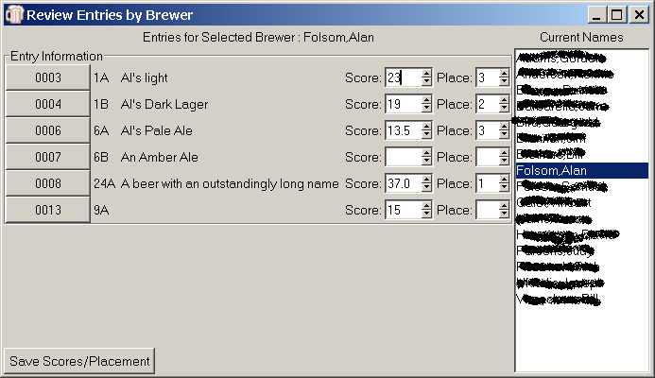
This provides an alternative way to select entries for editing, though the interface is essentially the same as “Edit By Flight Assignment.” In this case a list of entrants is shown to the right. When one is selected, the entries for that person are shown, and scores and place may be entered.

Again, click “Save Scores / Placement” to save your edits.

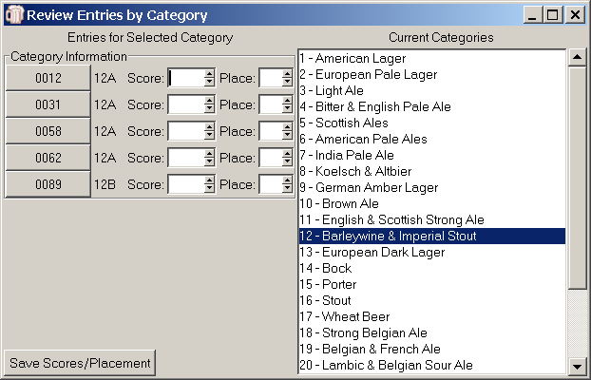
Edit Scores/Review Entries By Category

A final mechanism for entering scores is by Category. Again, select a category from the list to the right. All entries in that category will be shown, and scores and place can be entered. This might be most useful if your competition is run strictly along category lines.

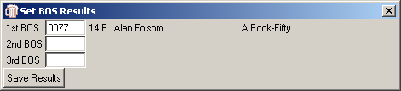
Enter Best Of Show Results

HCCP will record up to three places for Best of Show results. If entered, these results will show at the end of the score reports and the generated HTML file from the “Publish Results to HTML” option. In addition, the 1st place Best of Show will be added to the Comments field of the XML report generated for reporting to the BJCP.

Enter the entry number in the appropriate field of the “Set BOS Results” dialog. HCCP will verify that this is a valid entry number, and fill in information regarding it to the right of the entry number.

If no BOS results are entered, nothing will be displayed on the HTML or score reports. HCCP will only display
BOS results for fields which are non-blank, so if your competition only awards 1st BOS, leave the second and third fields blank, and they will not be included on the reports.

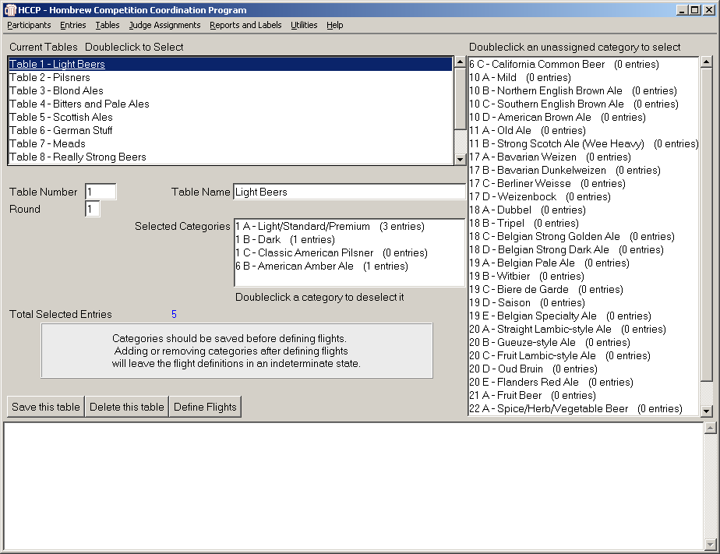
Tables

From the Tables menu item tab, you can select “Edit Table Definitions” or “Assign Flights to Rounds.” These are the options used to arrange your entries into manageable groups for judging.

Edit Table Definitions

The “Edit Table Definitions” selection is the mechanism to define tables by collapsing categories, and to define multiple flights if that is required. The dialog may appear busy, but is designed to allow easy definition of tables and the categories assigned to them.

At the top of the display is a list of the currently defined tables. Double-clicking on one of these entries will load the information for that table.

To define a new table, enter a unique table number, and provide it a name. The name is required, but can be any text.

To the right of the display is a list of category/subcategory pairs which are not yet assigned to tables, along with an indication of the number of entries in that category. Double clicking one of these will move it to the “Selected Categories” Box. Double-clicking in that box will unselect a category, and move it back to the unselected list. A running total of the number of entries assigned to this table is displayed in blue as “Total Selected Entries” so you can keep track of how large a table is becoming as you create it.

By default, all entries for a table are assumed to be in one flight, judged in round 1. If you wish to change the round (used when assigning judges) you may enter it here, though the “Assign Flights to Rounds” may be a clearer way to do this.

Define Flights

If the table is too large for a single judging session, you can divide it into multiple flights by clicking the “Define Flights” button. When first displayed this will show a single line with “Number of Flights” set to 1. To modify this, enter the number of flights you want in the “Number of Flights” box, and press return. This should bring up a display with entry boxes for each category for each flight, as well as the ability to assign rounds for each flight.

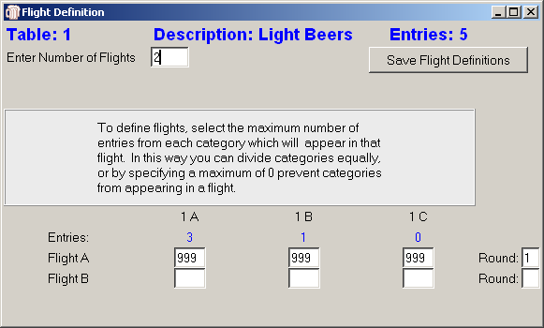
Just under each category/ subcategory name is a blue number indicating the current number of entries in that category. To assign entries to flights simply indicate the maximum number of entries from each category to assign to that flight. Lets say you have categories 5A, and 5B in a table, and there are eight entries in each. You wish to divide them. By entering ‘8’ in the box for 5A and 0 in the Box for 5B for flight A, flight A will get all the entries for 5A, and none for 5B. Alternatively, if you enter ‘4’ under both 5A and 5B flight Both flights will get 8 entries, 4 of each. Please be sure to have a large enough maximum in the last flight to handle all the unassigned entries. You may also assign different flights to different rounds here. You may assign flights to separate rounds (which might make a mini-BOS challenging)

This information is not preserved until “Save Flight Definitions” is clicked.

Note: Saving a table reinitializes information regarding it, including round assignment and flight definitions. If you “Save” from the table dialog, you must redefine flights and round assignments.

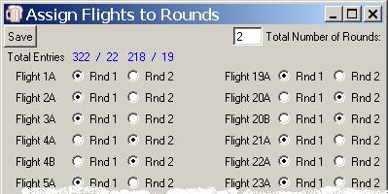
Assign Flights to Rounds

Under the “Tables” menu item you may also select “Assign Flights to Rounds”. This is an alternative mechanism for making round assignments, and may be the most convenient method to do so. Rounds divide the judging into set groups, such that judges can be assigned to multiple flights, as long as they are in different rounds. Rounds normally correspond to afternoon or evening judge sessions, as an example.

The popup will show a table with the current maximum number of rounds. You may increase this by entering a new number in the entry field and hitting <Enter>, after which the matrix will be resized to include the number of rounds you have specified.

The display will show in blue the total number of entries / flights assigned to each round, and will allow radio-button type entry of round assignments. (A Flight cannot be assigned to more than one round, and must be assigned to at least one.) There is no imposed limit on the number of rounds. If there are more than 254 flights, the table will wrap to a second column of assignments.

Judge Assignments

Assigning Judges to tables is traditionally one of the more awkward portions of running a homebrew competition. Judges may not like categories, may have preferences, and there is always the worry of assigning a judge to a table that may have his or her own entries. HCCP attempts to alleviate these problems as much as possible.

Two mechanisms are provided for assigning judges to flights. The matrix oriented dialog is convenient if the competition has on the order of 15-20 flights per round or so, and few enough judges that they can, or nearly can, fit on one view. The list based assignment dialog provides a mechanism to allow assignment of judges in much large competitions.
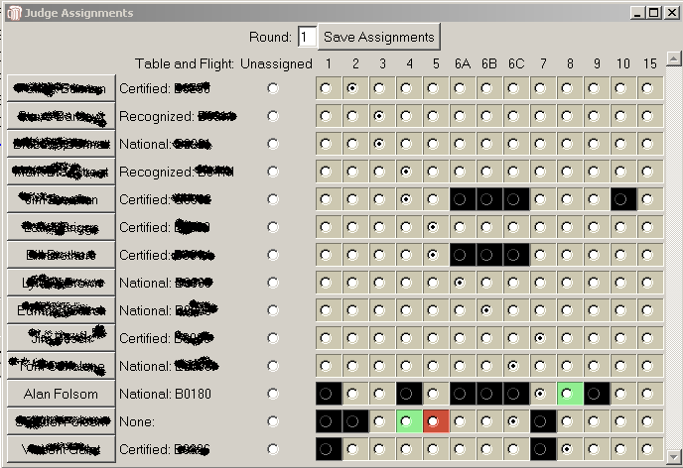

Matrix Based Judge Assignments

The “Matrix Based Judge Assignments” dialog is intended to minimize these problems as much as possible. Clicking on this menu item brings up a grid showing available judges, and Table/Flight for round 1. Flights which are not assigned to the current round are not shown. You may select a different round by entering it in the “Round” entry box.

The judges shown are those which were specified by checking the “Judge” checkbox on the “Participants” menu.

On the grid, the judge name is actually a button which will take you directly to that participant’s information for review, or to remove them from the judge list, if appropriate.

Following the name is their Judge Rank and ID, followed by a series of radio buttons. You may assign judges to tables/flights by clicking the appropriate radio button. Any tables for which a judge has an entry (regardless of the flight it is assigned to) will be black, and may not be selected. Categories for which a judge has expressed a preference will be highlighted in green, and categories which he or she dislikes will be highlighted in red. A judge can be idle for the particular round by selecting “Unassigned”.

Make your selections as you wish, and when satisfied, click “Save Assignments.”

While this selection process is easy here, it is not particularly easy to use this display to announce judge assignments. A printout is available from the “Reports” menu which will display this information in a format to easily read aloud, even if you just finished judging Barleywines.

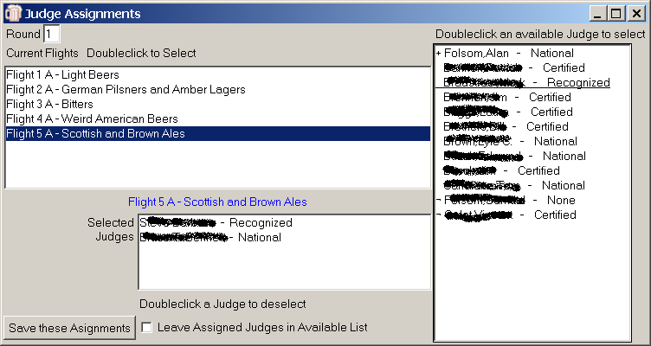
List Based Judge Assignments

This dialog provides an alternative mechanism for assigning judges to flights.

When you first access this dialog, no judges will be listed to the right. The flights for round 1 are shown. If you would like to work with a different round, enter it and press <Enter>.

When you select a flight by double clicking on it, a list of available judges Is shown to the right. “Available” is defined as judges that are not already assigned, and which have no entries in the flight you have selected.

In addition, judges which have expressed a preference for this category are shown at the top of the list, with a “+” preceding their name. If they have expressed a dislike for this category, they are shown at the end of the list, with a “¬” preceding their name.

Select a judge by double-clicking in the available list, and deselect by double clicking in the “Selected Judges” list. The interface is designed to mimic the table assignment dialog as much as possible.

At the bottom of this dialog is a checkbox titled “Leave Assigned Judges in Available List.” Some competitions will assign judges as soon as they are available, and continue flogging them, reassigning them to new flights as they complete the previous one. Essentially, this does away with the concept of “Rounds” as used earlier. When this checkbox is checked, judges may be assigned to multiple flights, to aid these types of competitions. As they return for a new assignment, they will be “available” and can be assigned to another flight. Be aware that this explicitly turns off one error checking aspect of HCCP. Do not check this box if you do not run your competition in this way!

Again, when you are happy with your judge assignments, click “Save these Assignments.” Note that the list based assignment option changes assignments for one flight at a time, whereas the Matrix based flight assignment views an entire round at a time, and saves the entire round’s assignments at one time.

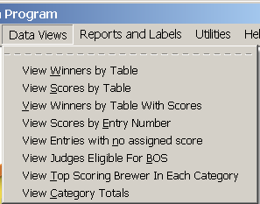
Data Views

Data Views are intended to provide a snapshop of the state of the competition to organizers as things go on. While there are many reports which seem to mimic the data views, the views are more likely to be used to see how things are progressing. “Report and Labels” will be used later to generate details of the competition, but the organizers may wish to see, for example, what categories have reported results so far. This is where the “Data Views” are useful.

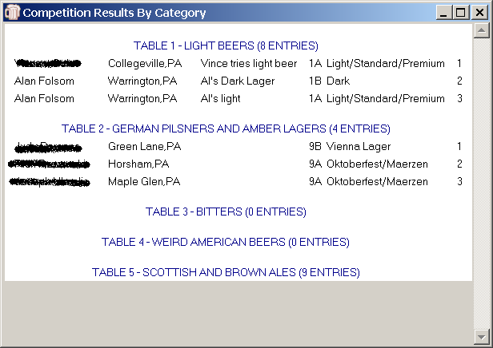

View Winners By Table

This view will show tables, and the winners that have been reported so far to them. If no winners have yet been entered, the table will be shown, but no winner information.

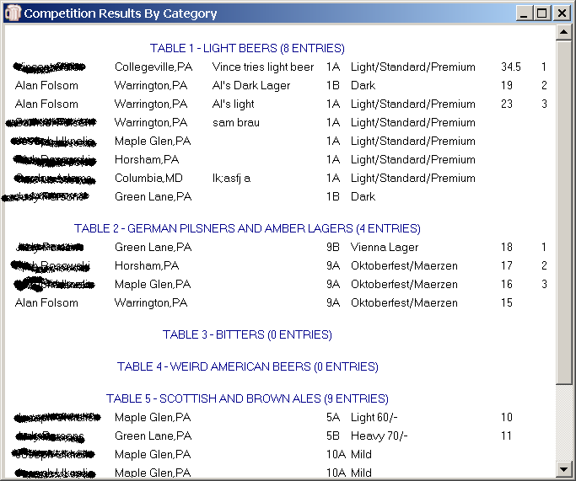

View Scores By Table

This view will show all the entries assigned to each table, and also show any scores assigned to the entries so far. It is a convenient way to review data entered for categories and tables.

View Winners by Table With Scores

This view simply shows the winners by table, along with the scores assigned to each entry. While of interest, perhaps, to the organizers, it is usually a bad idea to publish scores with winners, as entrants may not fully understand that the highest score may not necessarily win a category when a consensus must be reached among multiple judges.

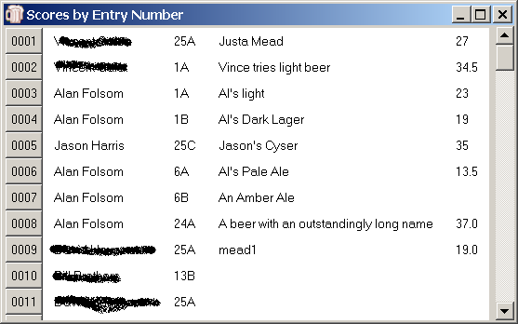
View Scores By Entry Number

This view lists all entries, and shows the scores assigned to them. The entry numbers are buttons which will take you to the entry dialog for the specific entry. You can use this view to quickly review entries that have or have not been scored, for example.

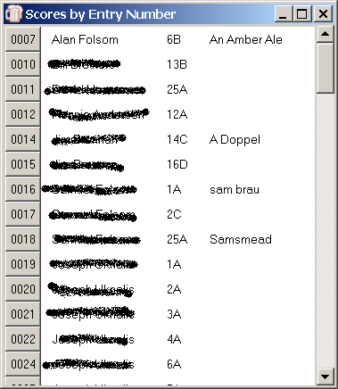

View Entries with no Assigned Scores

This view will show you the entries for which scores have not yet been entered. Again, the entry numbers are buttons which will take you directly to the entry dialog to modify or examine information as needed,

View Judges Eligible for BOS
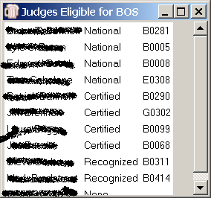

This view will show judges which have no entry eligible for Best of Show. This is determined by looking for entries which have a “1” in the place field.

The judges are sorted first by Judge Rank, and secondarily alphabetically by last name.

View Top Scoring Brewer in Each Category
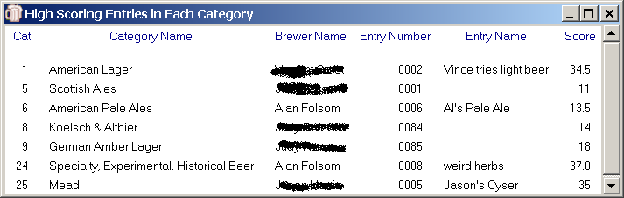
Probably of limited use, this view was intended to assist in competitions which advance entries based on category, such as the MCAB or AHA first round nationals. It shows the top scoring entry so far in each category, rather than by table assignment.

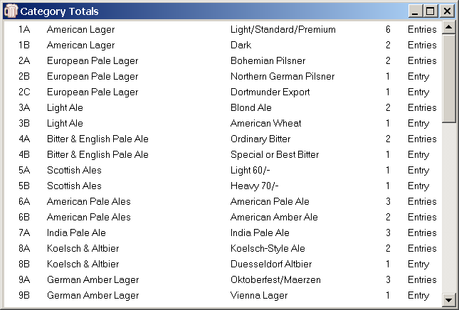

View Category Totals

View Category Totals provides a quick review of the number of entries in each category and subcategory.

Reports and Labels
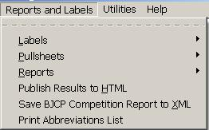
No software package that collects information is of any use unless that information can be accessed in a useful way. HCCP provides a number of reports, labels and utilities that access its database in useful ways.

Selecting “Reports and Labels” brings up a menu Labels, Pullsheets, Reports, Publish results to HTML or “Save BJCP Competition Report in XML. If a file “Ingredients.txt is found, the menu will also include “Print Abbreviations List.” Each of these will be discussed separately.

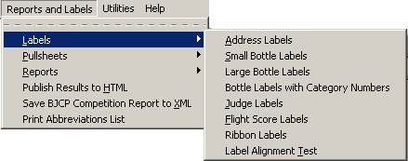
Labels

Labels can be printed on standard Avery 5160 sheets, or equivalent. HCCP provides a number of label types to simplify competition operation.

Address Labels
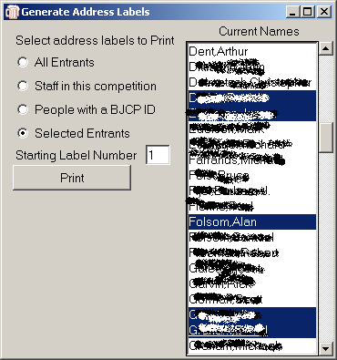
Printing address labels is sometimes the bane of competition organization. You may need to do a mailing to last year’s participants, to those who are on your staff, to a list of BJCP judges begging for their help, or whatever. HCCP provides a number of options for printing mailing labels based on the names in the Participants database.

You may select “All Entrants” which will print the labels for everyone with an entry in the current competition, useful for sending final reports.

“Staff” will print labels for anyone marked as an organizer, judge or steward.

“People with a BJCP ID” will print labels for anyone with a non-blank BJCP ID field in the database, for when you are soliciting judges.

Finally, you may select one or more people from the list, and print labels just for them.

The “Starting Label Number” will determine where on the sheet of labels the printing will start. This is a help especially at the end of the competition when you have many partially printed label sheets.
When you click the “Print” button you will be prompted to select the printer for the labels, and the printing will start.

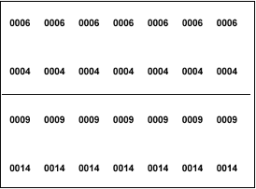
Small Bottle Labels
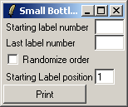
“Small Bottle Labels” provides an option for easily generating entry number labels. When selecting this entry, you provide a starting entry number and an ending entry number. HCCP will print labels with two entries per label, and seven copies of each entry number on each label. By carefully scoring these with an exacto knife or similar, you can peel off small labels to be affixed to the bottle, the cap, and the entry form. Seven copies of each number are provided to allow the neck and cap of each bottle for three bottles, plus one for the entry form.

HCCP will optionally randomize the entry numbers within the range you specified, so that sequential numbers are not necessarily applied to the one entrant’s entries.

Again, you may specify the starting label position for these labels, and you will be prompted for the printer for the labels.

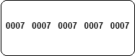
Large Bottle Labels

The “Small Bottle Labels” option mimics an earlier competition package, however the small labels may be difficult to cut, or to read. “Large Bottle Labels” provides an alternative label format.

The dialog is identical to the “Small Bottle Label” option, however only 5 labels are printed on each physical label. Typically one label would be affixed to the cap and to the neck of each of two entries, and the fifth would be attached to an entry form. These are provided for organizers wishing an organizer wishing an alternative to the smaller labels.

Bottle Labels with Category Numbers
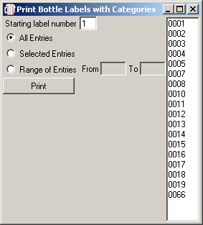
Some competitions wish to label bottles with the category and subcategory of the entry, as well as the entry number. Obviously, the entries must already be entered into the program for this labeling system to work. “Bottle Labels with Category Numbers” allows you to generate labels for bottles, four per physical label, with the category/subcategory numbers, and using a much larger font.

You may select the range of entries or individual entries for which to print labels. Since the entries must already be in the system, there is no need for the randomization of entry numbers, and it is not available on this dialog.

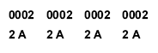

Judge Labels
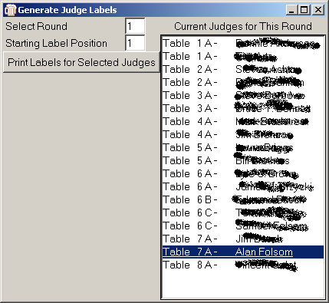
Judge Labels are intended to relieve the drudgery and possible error when Judges put entry number, category, subcategory as well as their name and rank on each score sheet.

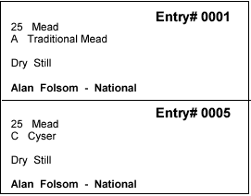
The dialog will show the flights for a selected round, and all the judges assigned to flights in that round. You may select one or more judges, and print these labels. For each judge selected, labels will be printed for each entry in his flight. He will receive a single sheet of labels which can then be put on the score sheets. The labels contain the required
information, and include the dry/sweet, still/sparkling and special ingredients information if appropriate for that entry.

Flight Score Labels
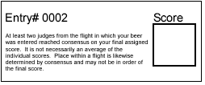

Flight Score Labels provide an alternative to the entry cover sheet, and may be affixed to the top score sheet for each entry. Essentially, they simply provide the fine print about scores that no one really wants to read. These may be printed for selected flights as needed.

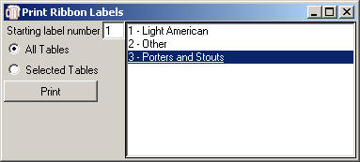

Ribbon Labels

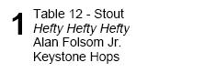
The “Ribbon Labels” option will print labels which can be affixed to the back of the ribbons often given to winners at homebrew competitions. You may select to print labels for all tables, or for specific tables. HCCP will find all entries marked with a place of “1”, “2”, or “3” and print labels showing the finish, the table number and name, the name of the entry in italics, if it exists, and the name(s) of the brewer(s). If the brewer specified a club, it will be printed also

Label Alignment Test

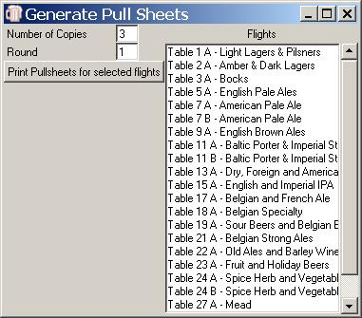
The Label Alignment Test will print a sheet of alternating color blocks, which should align with the boundaries of a sheet of labels. Every effort has been made to have HCCP work with any printer, but Windows printing is notoriously unreliable. This test may be used to verify alignment if needed.

Pull Sheets

HCCP provides pullsheets for both the individual flights, and for Best of Show. An effort has been made to make these large and clear, so that they are usable even after an hour of spills. To print pullsheets, you select the flights for which you want them, as well as the number of copies to print.

Table Pull Sheets
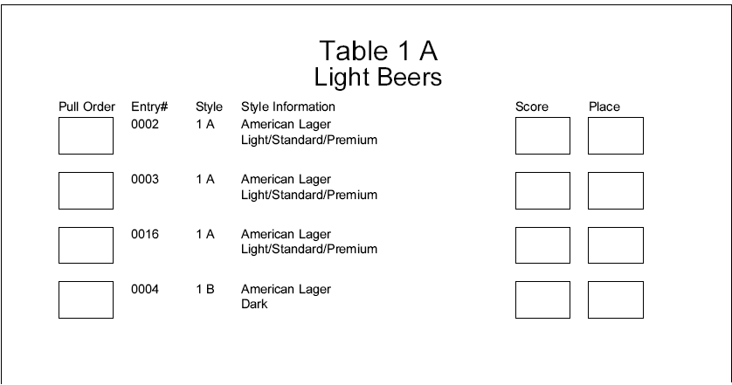
Each pullsheet is a full-sized printout. Information provided includes entry number, category and subcategory, and any special ingredients or still/sparkling dry/sweet information as appropriate.
Spaces are provided for judges to enter score and place. In addition, they may specify a pull order if they wish the stewards to bring the entries in something other than the default order.

Best of Show Pull Sheets

Best of Show Pullsheets are printed based on the entries in the database with a “1” in the place field. While not common, it is possible for no entry in a table to be awarded a 1st place. Such tables would not have a BOS entry. Similarly, it is possible for a tie to occur and have two entries marked as first. Both would be included in the BOS pullsheet. BOS pullsheets are identical to table Pullsheets, though the “Score” field is rarely used. Entries are sorted by Category and SubCategory.
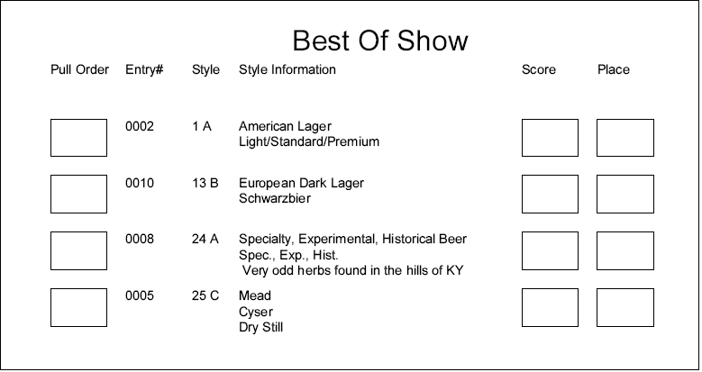

Reports

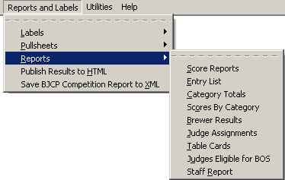
HCCP provides a variety of report formats, and it is likely that more will be added in future releases as requirements are determined.

For many of the report types, you have the option of printing to a printer, or to a file. When printing to a printer, formatting will be applied to the report using fonts, italics, bold, and so forth. If you choose to print to a file, the information is saved as a raw text file, so that it may be imported into any word processor and formatted as desired.

When printing to a printer, you will be prompted via a standard windows dialog to select the printer. When printing to a file, a standard dialog will allow you to select the file to which to save the information.

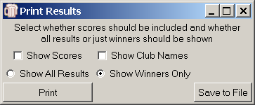
Score Reports

Selecting Score Reports will allow printing of results by table. Table name and number of entries will be shown, followed by the information for each table.

The first Checkbox allow you to select whether actual score value should be shown, or just placement/result information. Some competitions are sensitive about printing scores for general viewing.

The second checkbox selects whether club names should be printed with the results.

There are two radio buttons, providing an option to print either all the entries in each table, or just those with data in the “Place” database field.

In many of the report dialogs, including this one, you have the choice of printing to a printer, or saving to a file. In all cases, the Print button will give a formatted report on a selected printer, while the “Save to File” option will output unformatted text to a file for later use.

Entry List

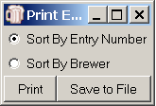
Entry List provides a simple list of the entries in the competition. They may be sorted purely by entry number, or first by brewer, and then by entry number. Each listing will show the entry number, category and subcategory, Brewer’s Name, Entry Name, and score, if any has been entered.

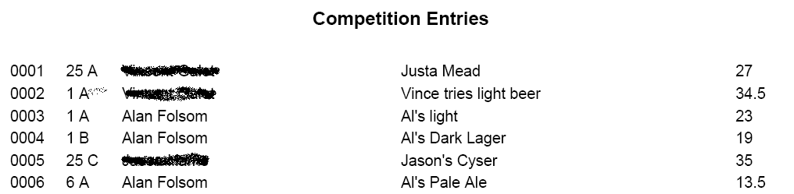

Category Totals

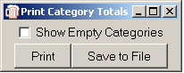
Category Totals will print the number of entries in each category and subcategory. You may chose to print or save to a file, and may optionally include categories for which no entries are in the database.

This may be useful for experimenting with table assignments of categories, for example.

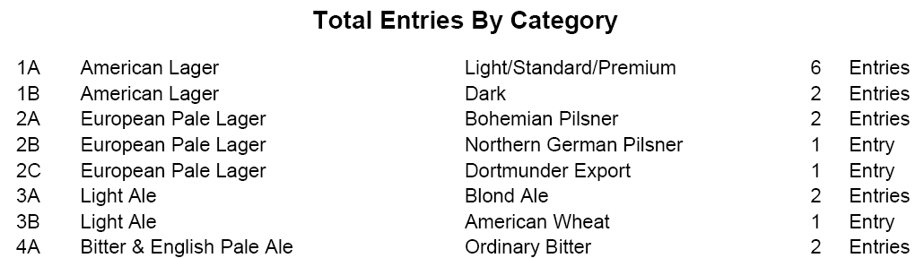

Scores by Category

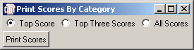
Scores By Category will bring up a dialog allowing you to select the top scorer, top three scorers, or all scores in a category. It will then print the highest scoring entry or entries in each Category (not subcategory) along with their entered category/subcategory, name, brewer, assigned score, and place if applicable. This may be useful for competitions such as MCAB qualifying events where results by category, rather than table, are needed.

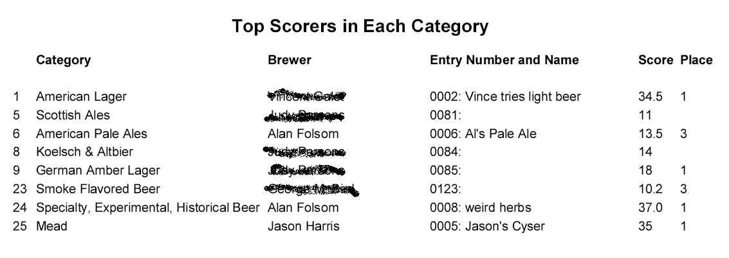

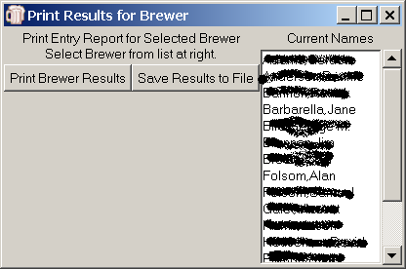
Brewer Results

Brewer Results prints a report intended to be returned to the entrant along with his scoresheets. It includes a table showing for each entry the entry number, entry name, category and subcategory place, and score. This is particularly useful when a brewer has entered multiple entries in one category/subcategory, but is a handy review for any entrant with more than one entry.

You select one or more brewers from the list shown. Results may be saved to a file or printed directly to a printer.

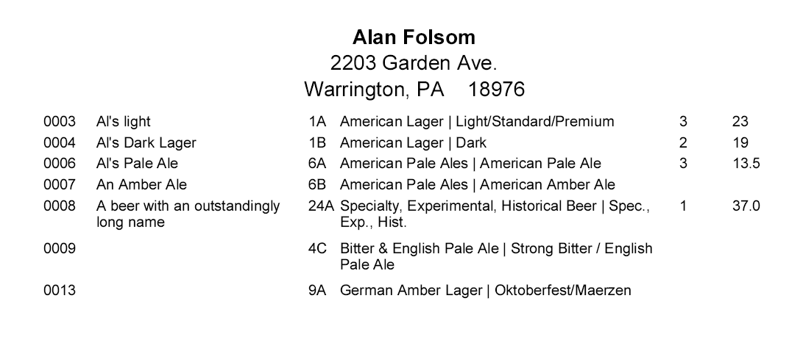

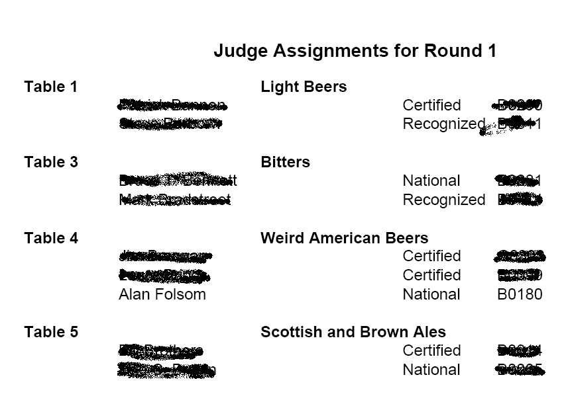

Judge Assignments

While HCCP provides two different interactive dialogs for assigning judges to tables and flights, neither is particularly conducive to reading out loud to judges in a noisy room. This option brings a simple dialog that allows you to select a round, and will print a table of the judge assignments for that round.

The printout is large, and suitable for posting on a wall, or whatever.

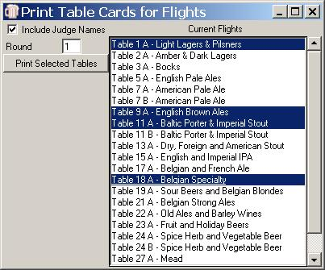
Table Cards

Table Cards prints large print signs to identify tables for judges and stewards. You may optionally select to have the names of the judges assigned to the selected flights included on the table card. (Just in case they didn’t hear your announcement from the preceding report.)

Judges Eligible for Best Of Show

Judges Eligible for Best Of Show prints a list of judges who do not have an entry eligible for BOS. The listing is sorted first by Judge Rank from highest to lowest, then alphabetically by name. The BJCP ID fields are displayed along with the judges’ names.

Staff Report

Staff Report prints a listing of all people labeled as an Organizer, Judge, or Steward. Organizers are listed first, followed by Judges, and finally stewards. For each listing, the Name, address, and BJCP ID is provided. This information may be printed to a file or to a printer, and should be useful when submitting competition results to the BJCP. This process may be better accomplished by using the “Save BJCP Competition Report to XML” option, discussed below. If you do not wish to use that, however, this report will provide a listing of people. No example is shown here, because I’d basically have to blot out all the information in the report….

Publish Results to HTML
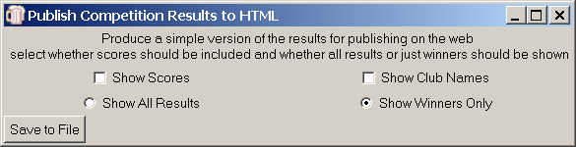
Most competition organizers are pressured to get the results viewable as soon as possible after a competition. This option is identical to the “Score Reports” report option, except that the results are saved to a file in HTML format. It is a complete html page and may be uploaded without further modification, or it may be used as a basis for generating other web page formats. If Best of Show winners have been specified, they will appear as a separate “table” at the end of the list. If no BOS winners have been entered, this table will not appear.

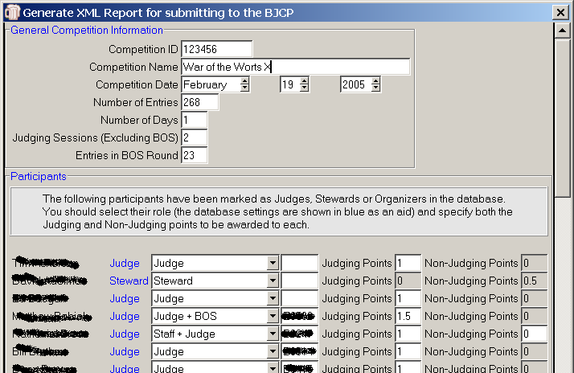
Save BJCP Competition Report to XML

It is important for competition organizers to report the appropriate information to the BJCP as quickly as possible following the completion of the event. In working to eliminate errors and make this as simple as possible, they have developed an XML report format, which contains the information needed, and also specified validation rules to be applied to the data. HCCP provides a mechanism for generating these reports in XML, which can then simply be emailed as the competition report.

The dialog is divided into three sections.

The first has general information about the competition. HCCP attempts to fill in this information as it can, but the fields are all editable. The “Competition ID,” Date, and Name can be all specified in the “Competition Information” section of the Utilities Menu item. If so, they will be entered here. “Number of Entries” is calculated from the database, and “Judging Sessions” is interpreted from the number of rounds configured. Finally, “Entries in BOS Round” is calculated from the number of Entries which have been awarded a “1” in the place database field.

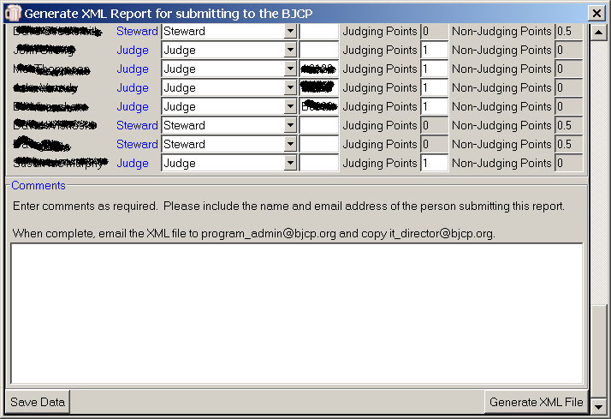
The second section of the dialog has information on participants. Each person listed in your database as a Judge, Steward, or Organizer will be shown, along with the BJCP ID if it has been entered. The text in blue, (Judge, for example) shows how the person was recorded in the database, but plays no role in the BJCP report. You must select a role from the pulldown list for each participant. HCCP makes its best guess from your assigned role, but this may be overridden by the drop-down box. In particular, HCCP has no knowledge of who served as BOS judges. Only the options provided are acceptable, and the program will not allow entry of other information. You must also determine the number of Judging and Non-Judging points HCCP attempts to guess at these values based on the number of rounds and days and the assigned roles, but you may, again, override the assigned values. HCCP will not allow assignments which do not fit the BJCP award requirements, as of the release date (June 1st, 2005).

The third section of the Dialog allows entry of freeform comments. At a minimum, this should at least include the name and email address of the person submitting the report. If a BOS winner has been specified, HCCP will include the name of the brewer and style in the comment field.

To save a snapshot of the data entered, use the “Save Data” button. This will store the data you have entered so far, and it will be automatically loaded when you next access this dialog.

When the data is correct, click the Button labeled “Generate XML File.” HCCP will first perform several validation rules against the data in the dialog. It will insure that the competition ID is a six figure number, greater than 100000, it will ensure that proper roles have been selected for each participant, and will ensure that either the BJCP ID field is blank, or it consists of the one of the letters A-G, followed by 4 digits. If blank, the participant will be reported as a non-BJCP registered person. Otherwise, they will be assumed to be in the BJCP program.

Assuming all data is valid, HCCP will then generate an XML file for sending to the BJCP.

Print Abbreviations List
When entering special ingredients for entries which require them, the entry field is sometimes too short to list all the ingredients. HCCP provides a mechanism for standardizing abbreviations for ingredients. On startup it looks for a file named “ingredients.txt” and if it finds one, enables the abbreviation mechanism. The file consists of an abbreviation, a tab character, and the item that is being abbreviated. When this is activated, another option on “Reports and Labels” appears, allowing you to print the abbreviation list.

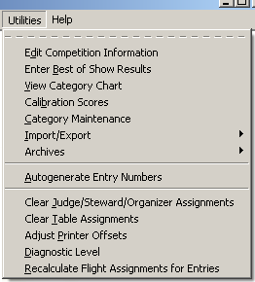
Utilities

The Utilities Menu item provides access to miscellaneous features not provided elsewhere. Included here, among other things, are the ability to save title information about the competition, and a very powerful facility for maintaining and modifying categories to be used in the competition.

Edit Competition Information
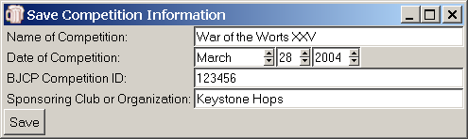

Edit Competition Information provides the ability to save the competition name, date, and sponsoring organization. This information will be included on several of the reports, if entered.

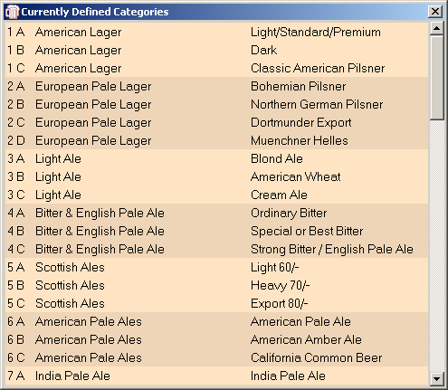
View Category Chart

Using View Category Chart you may view a scrollable chart of the currently defined styles and substyles. This will include any modifications that may have been made.

HCCP provides the ability to select from multiple style definitions, and to modify definitions for the current competition, from the “Category Maintenance” option. This chart will reflect any selections and modifications.

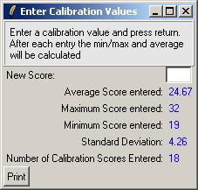
Calibration Scores

The Calibration Scores utility is a simple calculator for quickly entering scores for a calibration round. As scores are entered in the entry box, the minimum, maximum and average scores are calculated and displayed, along with the total number of scores entered. You can print the data for posting or announcement using the “Print” button.

Maybe not exciting, but it helps when you can’t find a calculator, early in the morning in the midst of trying to get a competition started!

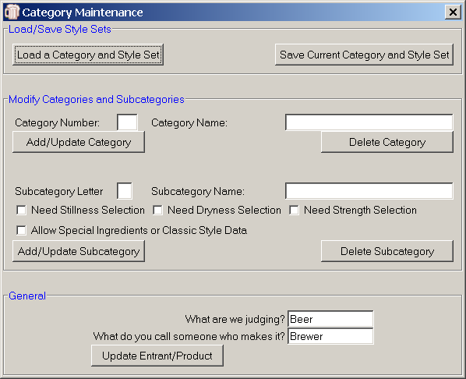
Category Maintenance

Category Maintenance is the mechanism for selecting a set of styles, or making modifications to the currently selected set. There are a wide variety of options here, as well as the ability to really mess up your competition information.

Category Maintenance should be done before any entries are recorded! Changing categories can cause entries to be listed as something entirely different from what they were entered as!

The Load a Category and Style Set button will bring up a file selection box with the currently available sets. These are saved in files with a “.styles” extension.

Four are provided with HCCP, including “BJCP04.styles” which is the currently accepted list of styles “BJCP99.styles” which are the old BJCP styles to be prior to 2004, “HWBTA.styles” which is a list of wine styles, and “Salsa.styles” which is a simplistic example of using HCCP for something unrelated to beer.

Save Current Category and Style Set will copy your current “competition.mk” database (remember?) to a new file for later use. It is not strictly necessary to save your modifications in this way, as they will be preserved in your competition database until such time as you reload it with another style set, but if you would like to preserve a new set of categories for future use, this will do so.

The next section of the dialog provides a powerful feature for building new categories and subcategories, or for modifying the information currently defining the categories.

To modify a category, enter a number in the Category Number field. When you press return or tab out of this field, the current category name, if any, for that category will be loaded into the Category Name entry box. You may change the name, or if this is a new category, add the new definition, by clicking the Add/Update Category button. The Delete Category button will remove that category from the database if it exists.

Each Category must have at least one subcategory defined, as HCCP uses the subcategory information for various purposes. Again you may enter a letter for the subcategory, and by tabbing out or entering a carriage return the current subcategory name will be loaded, if it exists. You may similarly change the name, or add/delete subcategories.

Also available on subcategory definition is the ability to determine whether that subcategory will allow specification of Stillness, Dryness, or Special Ingredients/Classic Styles. Using this mechanism you could modify the definitions to allow a “Still” Pilsner, for example, or special ingredients for an American Pale Ale.

If you have a special contest you may enter additional categories without affecting the current ones. For the “1st annual new parents brew-off” you could add category 99, “Beers that smell like diapers”, and have subcategory “A” be “Infected Beers” and subcategory “B” be “Lambics”.

To start with no predefined categories, delete or rename the “competition.mk” file and restart HCCP. No categories will be available, and all categories and subcategories will need to be entered through this dialog.

HCCP makes a valiant effort to be usable for other types of competitions. The last section of the category maintenance dialog provides a facility for contests for things other than beer. In most places where the program refers to “Beer” or “Brewer” these words can be replaced. The “HWBTA.styles” file, for example, uses “Wine” and “Vintner”, and when selected, will use those words throughout HCCP. In this dialog you may also enter a name for the product being judged, as well as what you call someone who makes it. This information is stored along with the Style definitions in the competition.mk database.

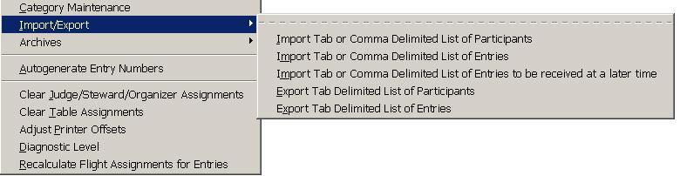
Import/Export

HCCP provides the ability to import and export both entries, and brewer information, in both tab and comma delimited file formats

The original intention was simply to provide a mechanism to import Judge information from the lists provided by the BJCP, but the mechanism was expanded when it was found to be useful in a variety of ways.

Import List of Participants

Import Tab Delimited List of Participants provides an option to import entrants from a tab delimited file. It is set up to directly import judges from the lists provided to each competition by the BJCP. The fields it expects are: FirstName LastName StreetAddress City State ZipCode Country Phone Nickname Email JudgeID and JudgeRank. If lists of participants other than BJCP judge lists can be coerced to this format, they may be imported also. Fields may be left blank, as long as the appropriate number of tabs are provided. A final, optional field is “Club” which may be used to import club affiliation. It is not provided by the BJCP, and is not needed by the dialog.

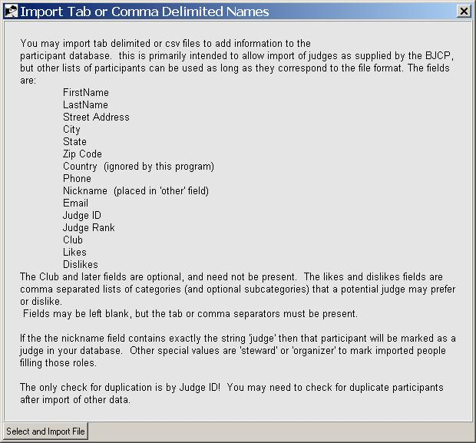
The only redundancy check provided is matching BJCP ID’s. If a match is found between the imported file and the current database, you are given the option of saving either the old or the new information.

If an entrant is read with the same name as an entrant already in the database but the BJCP ID field does not match, a subscripted letter is appended to the name in the entrant listboxes to make it clear that there are multiple entrants with the same name.

Import Tab Delimited List of Entries
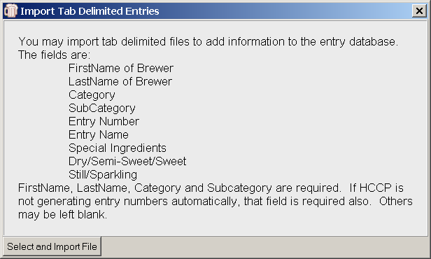
This option may be useful if entries are collected electronically via an online registration or similar mechanism.

HCCP will try to validate the entries, and load them into the database.

Import Tab or Comma Delimited List of Entries to be received at a Later Time

This option imports entries into the “To be received later” database. See “Add or Edit Entries to be Received Later on page 17 for details of how this database is used.

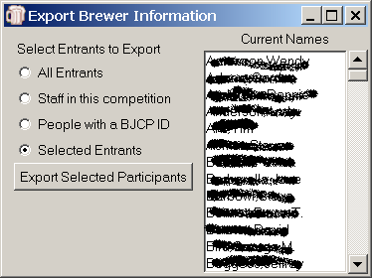
Export Tab Delimited List of Participants

This option will export participant information in a format identical to what it expects as import. Participant information can therefore be saved and reloaded if needed, or exported to another program.

The dialog mimics the Address Label dialog. You may select individual names to export, all entrants, staff, or people with a BJCP ID.

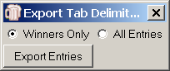
Export Tab Delimited List of Entries

This option will export entries in a format suitable to be re-imported.
Optionally you may select to export only entries which have some indicator in the “place” database field.

This option may be useful if you are running several rounds of a competition, wherein only qualifiers from an earlier round move on. Indicate in the first round entries which should be moved on by adding anything to the place field. Export those entries. Clear or rename the “entries.mk” database, restart the program, and import the exported list. You will now have a competition with only your winners from the first round.

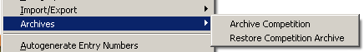
Archives

HCCP provides a mechanism to take a “snapshot” of the current database information, and save it to restore later. The “Archives” utility gives two options, “Archive Competition” and “Restore Competition Archive.” Archives are saved by copying all three main database files to a container file, ending with a “.archive” suffix.

This feature can be used either as a mechanism to store information from prior competitions, or as a means of doing a “backup” during the operation of the competition.

Archive Competition

This option will prompt for a new archive file name. When entered, the competition information will be copied to that file.

Restore Competition Archive

When selected, this option will first warn about overwriting current information. Then it will bring up a file selection dialog to allow selection of a file with a suffix of ”archive.” When selected, the data in that archive will be restored, overwriting any current database information.

Restoring an archive overwrites any current information! If you are not sure you want to do this, create an archive of the current information before doing a restore!!!

Auto Generate Entry Numbers

This feature provides an option to have HCCP generate entry numbers automatically, and sequentially, as entries are loaded. If your entries are being imported from an online registration mechanism, for example, which does not provide entry numbers, HCCP may be set to do this for you.

Many competitions may need to accommodate both manually numbered and entered entries, and ones which must have entry numbers generated automatically. A paradigm for doing this would be to put a dummy entry in the database with an arbitrarily large entry number. Manually entered numbers would be below this. When it is needed to have entries entered automatically, select this option, and HCCP will add entries after the highest number entered, thereby avoiding conflict with the manually entered values. When done, delete the dummy entry.

Clear Judge Steward Organizer Assignments
This option clears all indications in the database of Staff assignments. If your participant database is being shared among multiple competitions, this option should be used when first starting a competition to ensure that all previous judge assignments are deleted.

Clear Table Assignments

This option clears any indication in the databases of table and flight assignments, and judges assigned to tables or flights.

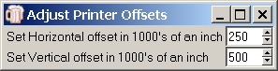
Adjust Printer Offsets

HCCP makes a strong attempt to print labels on all windows printers. It relies, though, on the printers being able to report programmatically what their minimum top and left margins are (as well as the printing resolution). In cases where labels do not appear to be aligning correctly, the left and top margins can be adjusted using the Adjust Printer Offsets option.

Diagnostic Level
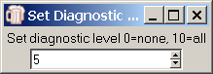
During the development of HCCP various diagnostics have been incorporated. These are prioritized on a scale of 1-10, with 10 being the lowest priority. At present, only diagnostic levels of 1, 5, and 10 are used. You can select the level of diagnostics to be printed with the Diagnostic Level selection. 5 is the default, but selecting 10 will cause a lot of information to be displayed in the lower portion of the main display, most of which is meaningless without knowledge of the internals.

Recalculate Flight Assignments for Entries

Assigning entries to flights is a compute intensive task, and the program does this only on startup, or when absolutely necessary. The Recalculate Flight Assignments option will force this to happen but should not be needed except in the case of program error. If table assignments are “missing”, or categories do not appear when assigning them to tables, this may clear the inconsistency.

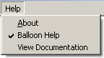
Help

Balloon Help
HCCP has, at this point, limited help facilities. By default, Balloon Help is provided. When the cursor is stationary over a particular field for 2 seconds, a yellow box will appear with information on that field, if available.
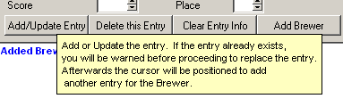
This may be enabled or disabled from the help menu item.

View Documentation
This option will display the HCCP Documentation (the file you are reading now) on the screen in Acrobat Reader™. Hccp.pdf must be in the same directory as the program, and you must have Adobe Acrobat™ installed on your computer.

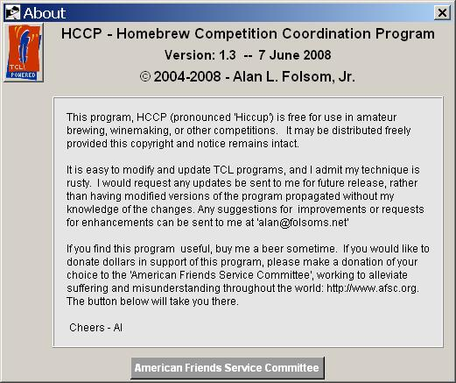
About

Databases
HCCP uses the Metakit database package provided by Jean-Claude Wippler of Equi4 software. Jean-Claude has made this package available free to the TCL community.

There are 3 databases used by HCCP. They are:

competition.mk | This database provides all style definitions. It is intended to be completely independent from the details of a specific competition
people.mk | This database has all the information relating to participants in the competition, excluding the data for any entries they may have. It may be preserved from competition to competition to avoid re-entering brewer or judge information. It is also possible to directly import the judge listings provided by the BJCP to avoid having to enter judge data
entries.mk | This database contains all the information regarding a particular competition. This includes entry data, table assignments, flight definitions, judge assignments, competitition title and date, and so forth.

The database tables are all optional. If they do not exist, empty versions will be created by the program when it starts. To start a completely new competition, it is sufficient to delete the entries.mk file. HCCP will start with the current style and participant information, but all dynamic data will be reset. To start cleanly with no competition or participant information, remove or rename the people.mk and entries.mk files.

If you wish to use HCCP to organize a competition with completely non-standard categories, or for some item other than beer (!), delete or rename the competition.mk database, and it will start with no predefined categories. I provide HCCP with 4 predefined sets of styles. BJCP04 is the current set of BJCP styles, BJCP99 is the definition of styles used prior to 2005, GABF04 is the style definitions from the 2004 Great American Beer Festival, HWBTA is the “Home Wine and Beer Trade Association” definitions for Wine styles, and “Salsa” is a simplistic set for judging salsas. Each of these can be selected from the Utilities/Category Maintenance menu. In addition, modifications or new style sets can be saved for later use.

The “people.mk” database may be shared among organizers of competitions within a region. Over time, most of the participants will be entered, eliminating much of the typing of entrant information. Information in this database is completely independent of specific competition information.

Glossary

It seems there is almost a regional dialect in the use of terms in homebrew competitions. Without arguing what is right or wrong, this section defines some common terms used in this program.

Category
A category is the larger of two style definitions provided in the style list (typically what is defined in the BJCP style guidelines). These include “Light Lagers,” “Porters,” and so forth.

Entrant
An entrant is a participant in the competition that has at least one entry being judged.

Flight
A Flight is the set of entries judged by one set of judges in a session. It may be one of several flights in a “Table,” which means there will necessarily be some run-off competition among the flights of that table.

Organizer
HCCP tags certain participants as “organizers”, meaning they are involved in the running of the competition. Note that the BJCP recognizes just a single organizer, and the rest are “staff.”

Participant
A participant is someone involved in the competition, either as a judge, steward, organizer, entrant, etc.

Round
A Round is a single judging session. Competitions may have a morning and afternoon round, or if the competition spans more than one day, even more than that. In general, judges judge only one flight per round.

Subcategory
Categories are typically divided into subcategories, as in Robust and Brown subcategories being part of the Porter Category. HCCP requires that each Category have at least one subcategory, and that every entry be tagged with a category and subcategory, even if there is only one subcategory in the category.
I apologize if this offends anyone’s aesthetics.

Table
A Table is a collection of entries which will be judged against each other. It may consist of one category, or multiple categories may be combined to form a table. If there are more entries in a table than can be conveniently (or safely) judged by one set of judges, it may be split into multiple flights.

